client/server DBMS

🧠 What is a Client/Server SQL Database?
# Source: AI Source: Provided by: [Data Path: Persons Table -> ID Column: 1, Name_En Column: Motasem Essam] -> From: [ChatGPT] on [6/10/2026]
A client/server SQL database is a system where:
- A client (like SSMS, a web app, or script) sends SQL queries.
- A server (like SQL Server, MySQL, PostgreSQL) processes those queries and returns results.
✅ The server runs the SQL engine that:
- Stores and manages the data
- Processes queries
- Enforces security and consistency
✅ The client is just the interface — it doesn't store or process data directly.

🧱 How It Works
# Source: AI Source: Provided by: [Data Path: Persons Table -> ID Column: 1, Name_En Column: Motasem Essam] -> From: [ChatGPT] on [6/10/2026]

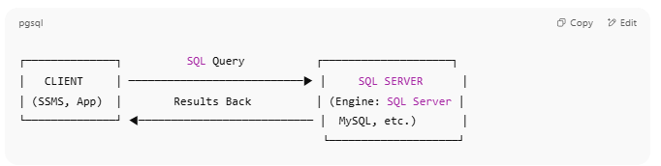

┌──────────────┐ SQL Query ┌────────────────────┐
│ CLIENT │ ───────────────────────────▶ │ SQL SERVER │
│ (SSMS, App) │ Results Back │ (Engine: SQL Server │
└──────────────┘ ◀─────────────────────────── │ MySQL, etc.) │
└────────────────────┘

✅ Examples of Client/Server SQL database
# Source: AI Source: Provided by: [Data Path: Persons Table -> ID Column: 1, Name_En Column: Motasem Essam] -> From: [ChatGPT] on [6/10/2026]
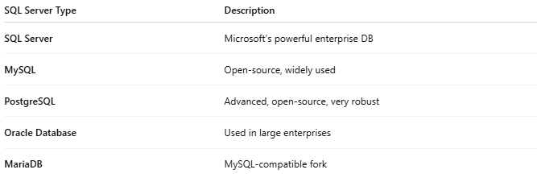
SQL Server Type | Description
SQL Server | Microsoft’s powerful enterprise DB
MySQL | Open-source, widely used
PostgreSQL | Advanced, open-source, very robust
Oracle Database | Used in large enterprises
MariaDB | MySQL-compatible fork

🔑 Key Features of Client/Server database
# Source: AI Source: Provided by: [Data Path: Persons Table -> ID Column: 1, Name_En Column: Motasem Essam] -> From: [ChatGPT] on [6/10/2026]
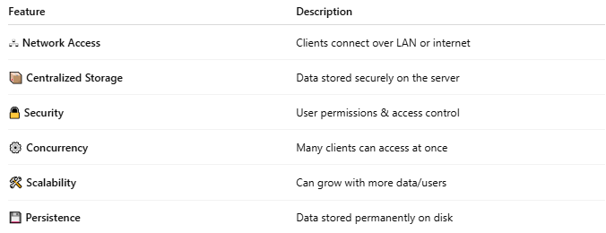
Feature | Description
🖧 Network Access | Clients connect over LAN or internet
📦 Centralized Storage | Data stored securely on the server
🔒 Security | User permissions & access control
⚙️ Concurrency | Many clients can access at once
🛠 Scalability | Can grow with more data/users
💾 Persistence | Data stored permanently on disk

🆚 How Is It Different From File-Based DBs?
# Source: AI Source: Provided by: [Data Path: Persons Table -> ID Column: 1, Name_En Column: Motasem Essam] -> From: [ChatGPT] on [6/10/2026]

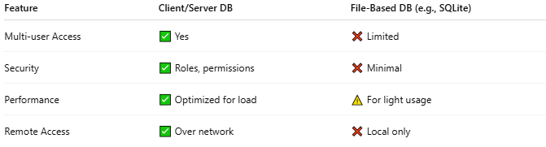
Feature | Client/Server DB | File-Based DB (e.g., SQLite)
Multi-user Access | ✅ Yes | ❌ Limited
Security | ✅ Roles, permissions | ❌ Minimal
Performance | ✅ Optimized for load | ⚠️ For light usage
Remote Access | ✅ Over network | ❌ Local only

📌 Real-World Example
# Source: AI Source: Provided by: [Data Path: Persons Table -> ID Column: 1, Name_En Column: Motasem Essam] -> From: [ChatGPT] on [6/10/2026]
- You open SQL Server Management Studio (SSMS) (the client).
- It connects to SQL Server database running on your machine or a remote server.
You run:
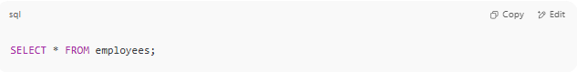
SELECT * FROM employees;
- The server processes the query and sends results back to your client.

